Ms. Watanabe • Room 146 • Lesson 2
Directions:
1. Practice the words to know
2. Read the “Story of the Week”
3. Highlight/underline the words to know in the story
Words to Know
look | he | have | what
too | for
Story of the Week: “The Storm”
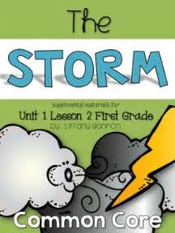

Tuesday | Wednesday | Thursday | Friday
Color in box when all steps are completed | Color in box when all steps are completed | Color in box when all steps are completed | Color in box when all steps are completed

Story of the Week
“The Storm”
Pop has come in. Look! He is wet. Tim and Rip ran to him. Tim, Rip, and Pop have fun. Tim had to go to bed. What did Tim and Rip see? Tim hid in his bed! Rip hid, too. Look what Pop had for Tim. Tim had a sip. Pop had a hug for Tim. He had a hug for Rip, too. Pop sat with Tim and Rip.

